EXP NO 6:
CREATE A SIMPLE CLOUD SOFTWARE APPLICATION FOR PRODUCT SELLING USING ANY CLOUD SERVICE PROVIDER TO DEMONSTRATE SAAS.

AIM: To create a simple cloud software application for product selling using any cloud service provider to demonstrate saas.
procedure:
step1: go to zoho.com
step 2: login to the zoho.com
step 3: select one application
step 4: enter application name
step 5: created new application
step 6: select one form
step 7: the software has been created.
Output
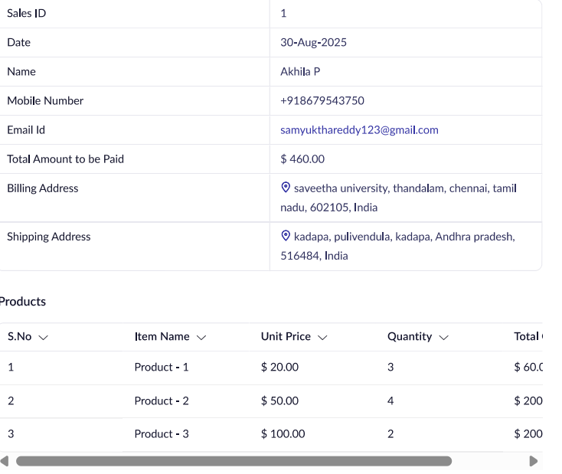

RESULT:
Successfully created a simple cloud software application for Product selling using any cloud service provider to demonstrate SaaS

